缩减变量的Y2模型,变量参见下方.

# 97-15年:

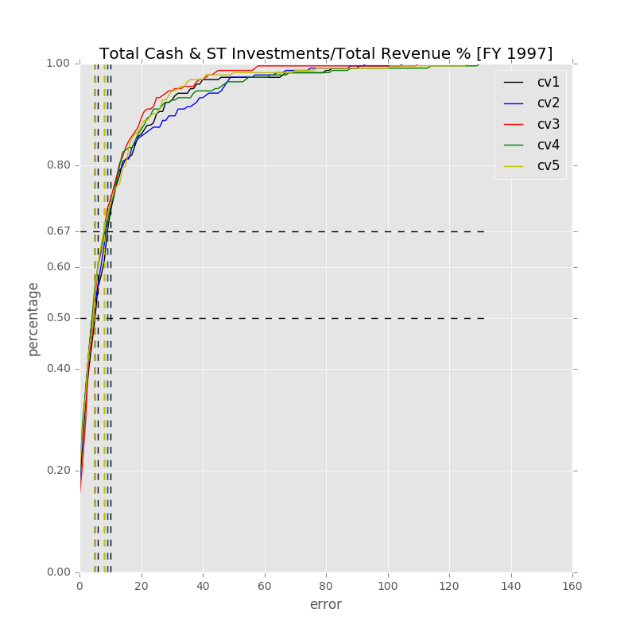

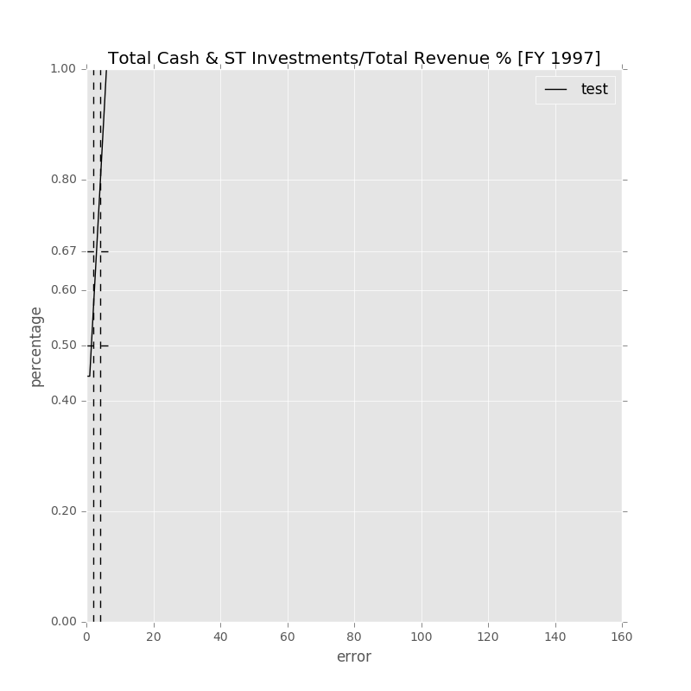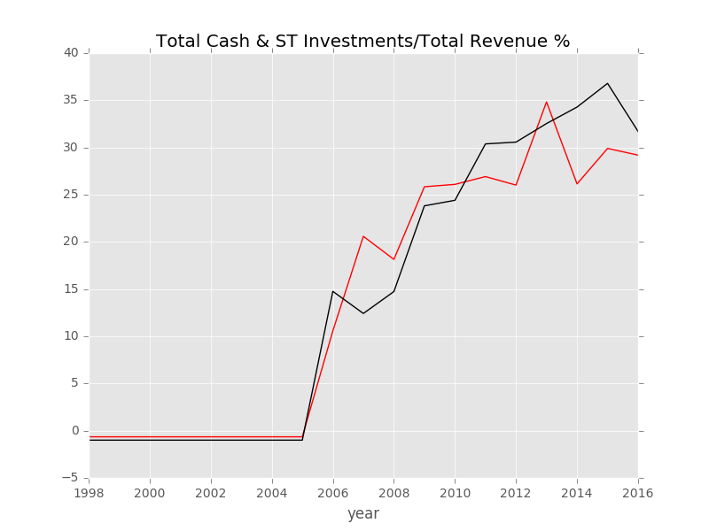

Label: Total Cash & ST Investments/Total Revenue % [FY 1997]

Min Error: 0.283557

Mean Error: 2.516677

Median Error: 2.098184

Max Error: 7.864540

Feature importance:

Gross Margin % : 0.095022

Net Property, Plant & Equipment/ Total Assets % : 0.084473

Net Income Margin % : 0.082236

Rev YOY % : 0.080999

Total Liabilities/Total Assets % : 0.079842

Total Asset Turnover : 0.079646

Avg. Cash Conversion Cycle (Days): 0.078780

R&D Exp./Total Revenue % : 0.077335

Cash from Ops./Net Income% : 0.075035

Return on Equity % : 0.067299

Goodwill/Total Revenue % : 0.065930

Total Debt/Equity % : 0.065634

Payout Ratio (%): 0.041444

准入资本市场难度: 0.019253

Cash flow risk(0:low; 1: high): 0.007073

Total Min: 0.283557

Total Mean: 2.516677

Total Median: 2.098184

Total Max: 7.864540

# 10-15年

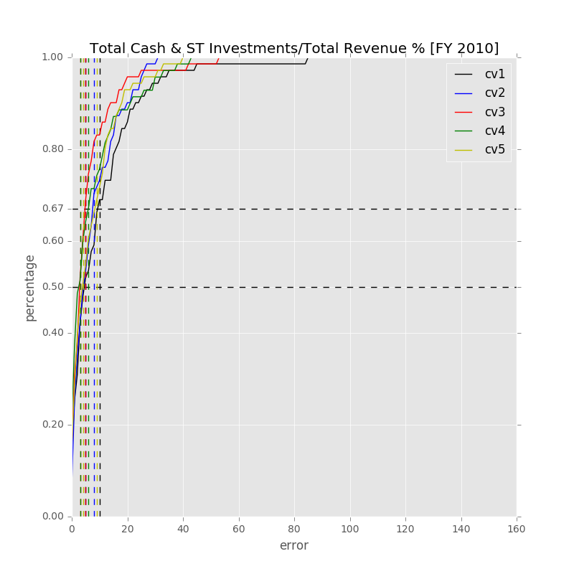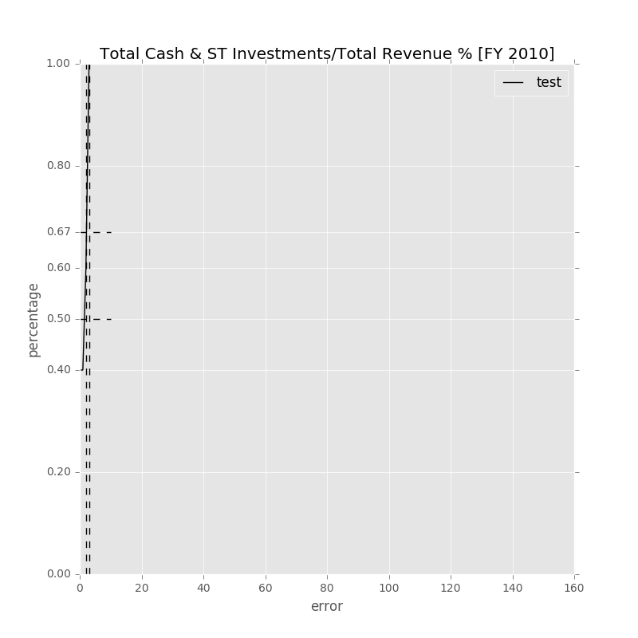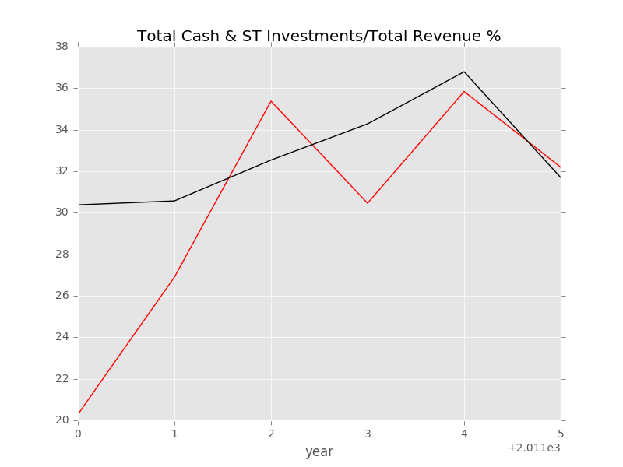

Label: Total Cash & ST Investments/Total Revenue % [FY 2010]

Min Error: 1.161051

Mean Error: 3.236386

Median Error: 2.920548

Max Error: 6.654630

Feature importance:

Total Asset Turnover [FY 2010]: 0.086521

Net Property, Plant & Equipment/ Total Assets % [FY 2010]: 0.082872

Goodwill/Total Revenue % [FY 2010]: 0.082809

Net Income Margin % [FY 2010]: 0.082358

Gross Margin % [FY 2010]: 0.081402

Total Liabilities/Total Assets % [FY 2010]: 0.081295

Avg. Cash Conversion Cycle [FY 2010] (Days): 0.076126

Cash from Ops./Net Income% [FY 2010]: 0.073885

Rev YOY % [FY2010]: 0.072789

Return on Equity % [FY 2010]: 0.071063

Total Debt/Equity % [FY 2010]: 0.070856

R&D Exp./Total Revenue % [FY 2010]: 0.063388

Payout Ratio [FY 2010] (%): 0.047652

准入资本市场难度: 0.020516

Cash flow risk(0:low; 1: high): 0.006467

Total Min: 1.161051

Total Mean: 3.236386

Total Median: 2.920548

Total Max: 6.654630